**Bonaire’s Strategic Challenge**

*“... Going forward in a complex world, governance, execution capacity, and long-term funding, are all in short supply for the needs of Bonaire. Each needs to be addressed. We need an apolitical and independent but locally endorsed “strategic institution” that has the ability to think strategically about the future, and execute efficiently on each area of development important for Bonaire. Such an institution must strike a fine balance. It can’t be “too far” from Bonaire’s day-to-day realities, that it doesn’t understand local circumstances. But it also can’t be “so far” from The Hague that it has no national ownership and engagement.*

*The world will keep throwing complex challenges to Bonaire. We need to face up to them and deal with these strongly and confidently. Our future has to change from our past. In fact, that is the big opportunity out of this crisis. And if we don’t avail of this chance, the fault will not be in our stars but in ourselves. Declaring victory and going back to “business-as-usual” will be failure. Let us not believe otherwise ...”*

*– Adnan Hassan*

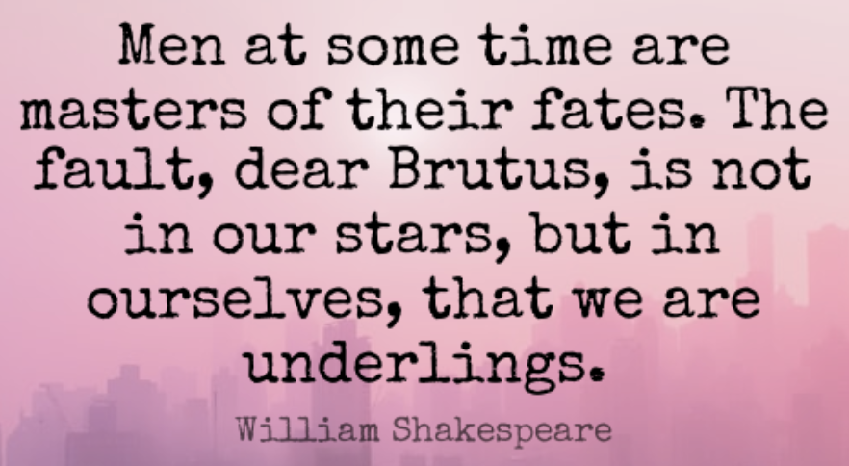

We live in a global village. In a complex and globalized world, “*no island is an island*.” Some may have thought that Bonaire was far from the world’s troubles. As we found out with COVID-19 pandemic, this is not so. We may be an island but we are affected by what happens elsewhere.

Going forward the ability to proactively understand global trends will be at premium. Small communities will increasingly be forced to make tough and complex strategic choices. Mistakes will have costly consequences. Paralysis will lead to lost opportunities. Heading in the wrong direction, even if done efficiently, will not be worthy of praise.

Bonaire’s future is unclear because we are unprepared for a complicated and inter-connected world. To succeed, we need to develop the ability to take and execute strategic decisions. It will require strong, smart and confident leadership. If we can’t develop this leadership, there will be no one to blame but ourselves.   
  
Some say it isn’t fair that such a heavy burden of strategic decision making is placed on a small island. But such is life. Welcome to the first century of the 3rd millennium.

How has Bonaire done so far with a complicated world? Our overall handling of the COVID-19 pandemic gives us some insight. While discrete tasks might be handled well, strategic ones are messed up. And this is the heart of our strategic challenge: not just do small things well, but get the big decisions right, proactively.

Let me explain.

Recently I got shot on Bonaire. And am glad for it.

I got my COVID-19 vaccination shot on March 29th. The process was efficient, and the relevant organizations (OLB, RIVM, Fundashon Mariadal, etc.) deserve praise. From start to the vaccine shot, it took all of 3-5 mins. The system worked. The process was clear. The staff was courteous. The environment clean. The supervisors appeared engaged. To ensure that there were no side effects, a 15-minute wait followed the vaccine shot. It was all over in around 20 minutes.

Behind the scenes a lot of logistics happened.   
  
The system managed to get an accelerated dose of vaccines from European Netherlands via a global chain. US giant Pfizer supplied the Netherlands with a vaccine designed by German lab BioNTech, from its plant in Puurs, a Flemish town previously better known in Belgium for a brand of beer, Duvel. That vaccine was kept at -70c as it flew via KLM to Bonaire. It got to the Fundashon Mariadal then to the Sporthal vaccination site, and in the hands of nurses, that injected my upper arm, on schedule, with no mistake. Well done Bonaire. Wow!

Now, why can’t the rest of life on our island work like this?

Sadly, the successful vaccination process is not symbolic of Bonaire’s general effectiveness. And it certainly is not a symbol of how Bonaire has handled the overall COVID-19 crisis.

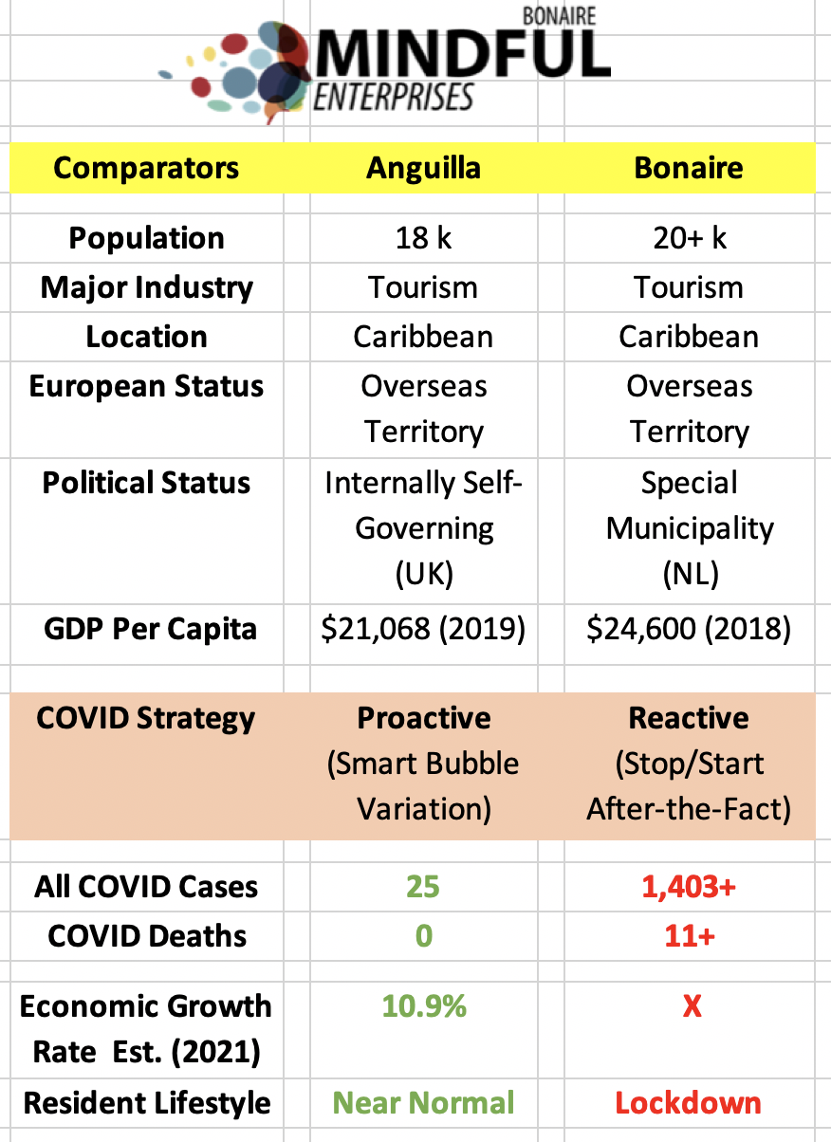  
Since the pandemic started, to date, Bonaire has had 1,403+ infected cases, 11+ dead, and the economy is destroyed.

In the same time period, a similarly positioned Caribbean island, Anguilla, had only 25 infected, 0 dead, and their economy is positioned to grow by 10.9%.   
  
This data does not lie. It is hard not to stare at this comparison between Anguilla and Bonaire, and realise the extent of our strategic failure.

Some say “*We were doing well, and have had bad luck with the British variant*.” Ironically, Anguilla is a British island, so one could argue, even more susceptible to the “British” variant.

Shockingly, we had strategic choices that were ignored. For over 9 months, Bonaire was advised by some to be proactive and follow the “Smart Bubble” approach. Variations of this approach were being put in place successfully in places as far apart as Anguilla, New Zealand, Taiwan, etc. But this counsel was ignored – even mocked – with the results now indisputable.  
  
Even an accelerated vaccination and well-run program coming out of our strategic failure, and accelerated testing, may not be enough. We need to get to around 75% of vaccination to get “herd immunity.” The unwillingness of enough to take the vaccine, and the presence of variants, will likely make the corona crisis an on-going and more long-term concern. Our approach has to turn from a sprint into a complex and strategic marathon.   
  
Let us get one other thing out of the way. Many people in our community – both on Bonaire, and those helping us at the national level – are sincere, hardworking and under a lot of pressure. They work under tough conditions and with total devotion. So, my criticism does not dispute their incredible sacrifices. In fact, the successful management of the vaccination process is indicative that discrete tasks can be handled well.

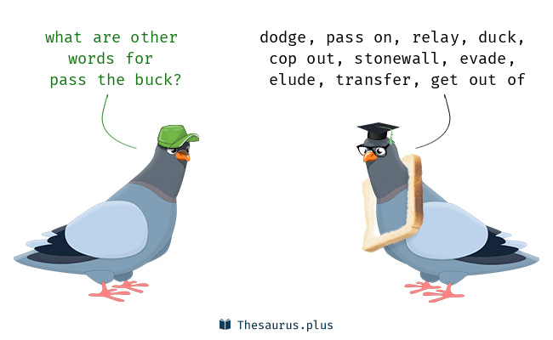But overall, Bonaire did not protect lives; nor livelihoods. This is clear. So, someone(s) failed on the bigger strategic goal. And if the blame is not to a single individual, or smaller groups, then our collective leadership failed to think strategically. That is, the “system” in both Kralendijk and The Hague failed to analyse the issue correctly and act decisively. Hard work does not protect against inexperience nor ineptitude at this level.

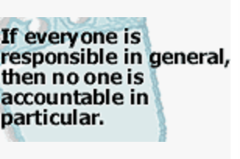

No one is thinking adequately about strategic issues that affect Bonaire. If they were, our situation would be different. Where there are accountabilities, these are too diffused. Actions are reactive. And when failure happens, there is a lot of finger pointing. But ultimately no one’s head is on the chopping block and the “*buck stops at no one.*”

Without strategic outlook, and with diffused accountability, no one can be held accountable or even succeed. And this issue is not academic. It is a structural problem. Our status as a “Special Municipality” has created a diffusion of responsibility where ultimately no one is responsible.

Bonaire’s complex strategic problems won’t get solved just at the national level. Neither should they. We can’t and shouldn’t just look to European Netherlands to solve this. As far as the national public is concerned, the Dutch Caribbean is an afterthought. Getting our collective issues on the national table is an ongoing struggle. The Hague gets overwhelmed with the decisions that need faster turnaround, especially if they require inter-ministerial coordination or cabinet involvement. Moreover, when politicians and policy makers do pay attention, the big three (St. Maarten, Aruba and Curacao) get the main focus, and they have very different circumstances than the smaller three (Bonaire, Saba, Statia). In fact, within the smaller three, each is different.

Dedicated “ambtenaren” at the national level may understand our issues. But even for them it is hard to place our issues at the inter-ministerial level, forget on the national agenda. Bonaire has uniqueness that cannot be managed with suitable nuance by national politicians who also have to attend to a national public that has little time or understanding of the Dutch Caribbean, and certainly not of Bonaire.

Thoughtful people in both Bonaire and The Hague understand this constraint and the systemic strategic failure, at least at an intuitive level. Maybe they can't always admit it, at least not publicly. But they get it. After all, how can you not?! Just look around.   
  
Bonaire’s strategic development process is currently under-qualified for strategic tasks, and structurally not set up to deal with hard complex choices. Our failures will have long lasting consequences if not fixed. We cannot, and should not rely on our constitutional set up as a “Special Municipality” to bridge this failure of complex decision-making.

Our local “policy machine” does not connect into the national strategic capacity in an adequate, let alone a seamless, manner. Yes, there is regular dialogue back-and-forth with the national level. But it is sometimes after-the-fact and tentative. Worst, silos of factions on both sides of the Atlantic, are unable to effectively coordinate among themselves. They can’t consequently act strategically; nor holistically.   
  
This overall strategic flaw was somewhat obvious with earlier failed projects, with roads, sewage, energy, etc. being high on the list. A recent significant failure was Bonaire’s expensive project to develop a Masterplan 2030. It was launched with great fanfare, engaging the whole community. But then collapsed into nothing. Sure, the COVID-19 pandemic drew away management attention. But to use this as the reason for inaction is a confession that our machinery is overwhelmed and inadequately resourced for even important tasks. The shocking inability to adjust to the current unprecedented crisis with the COVID-19 pandemic is probably one of the most consequential strategic failures – with deadly consequences. In each situation, we couldn’t see outside the box.

The current vaccination program is a discrete task that is being run well. But this does not excuse the strategic failure of not managing the overall COVID-19 pandemic. Brushing the failings aside and just moving on to the next crisis, is unwise. Admitting a problem is a big step towards addressing it.

Going forward in a complex world, **governance, execution capacity, and long-term funding**, are all in short supply for the needs of Bonaire. Each needs to be addressed. **We need an apolitical and independent but locally endorsed “strategic institution” that has the ability to think strategically about the future, and execute efficiently on each area of development important for Bonaire.** Such an institution must strike a fine balance. It can’t be “too far” from Bonaire’s day-to-day realities, that it doesn’t understand local circumstances. But it also can’t be “so far” from The Hague that it has no national ownership and engagement. Ultimately, the solutions will have to come from Bonaire, but in partnership with The Hague.

The world will keep throwing complex challenges to Bonaire. We need to face up to them and deal with these strongly and confidently. Our future has to change from our past. In fact, that is the big opportunity out of this crisis. And if we don’t avail of this chance, the fault will not be in our stars but in ourselves. **Declaring victory and going back to “business-as-usual” will be failure.** Let us not believe otherwise.

----------------------

By Adnan Hassan

Investor. Advisor. Author. Entrepreneur.

Founder & Co-CEO, Mindful Enterprises, B.V. (Bonaire)

Vice Chairman, Mindful Spirit Foundation, (Bonaire)

Founder, Bonaire Future Forum, The BIG Ideas Foundation (Bonaire)

*Formerly with the World Bank Group Board of Directors, Washington, D.C.*